**EXPT-3**

**SERVLET PROGRAM – “HELLO WORLD”**

**AIM:**

To create a servlet program that prints “ Hello World “.

**CODE:**

* Click nbfs://nbhost/SystemFileSystem/Templates/Licenses/license-default.txt to change this license

*/

package com.mycompany.mavenproject1;

public class Mavenproject1 {

public static void main(String[] args) {

System.out.println("Hello World!");

}

}

**OUTPUT:**

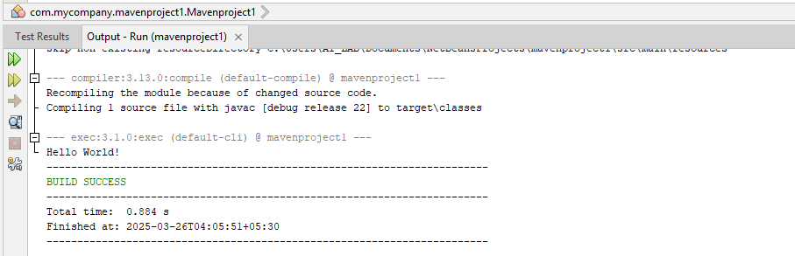

**RESULT:**

Thus the servlet program and output has been executed.